SYD—3536
Cleveland Open Cup Flash Point Tester

Operation Manual

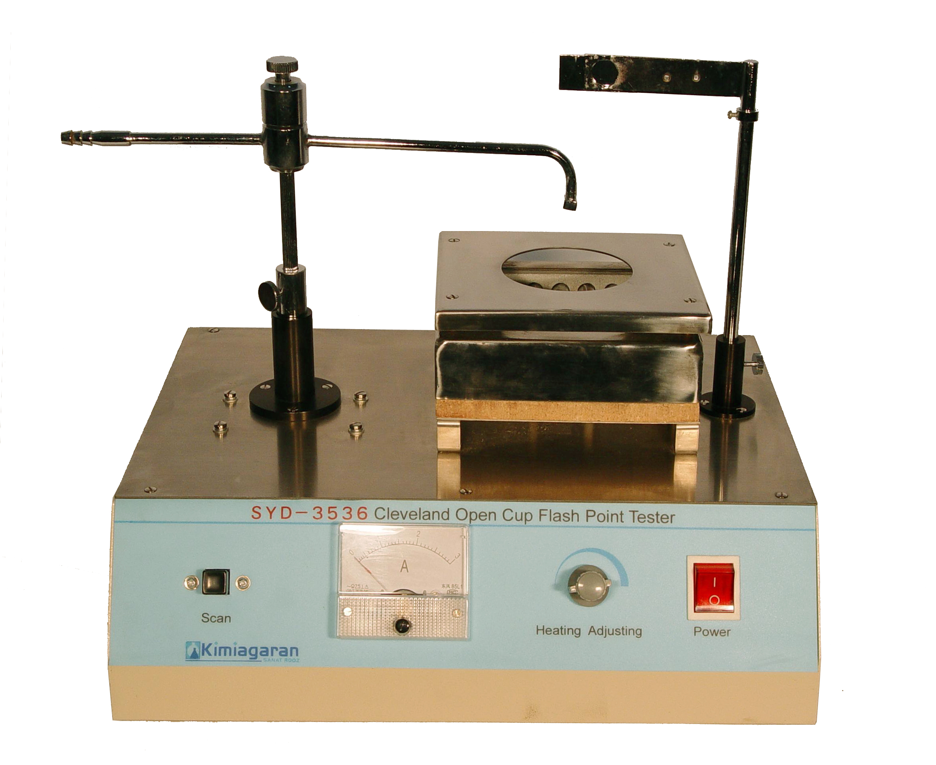

Contents

Ⅰ.Standard…………………………………………………2
Ⅱ.Purpose and using range ………………………………2
Ⅲ.Instrument working surroundings ……………………2
Ⅳ.Main technical specifications and index………………2
Ⅴ.Main structure and electrical principal fig……………2
Ⅵ.Installation for the instrument…………………………3
Ⅶ.Notice proceeding………………………………………3
Ⅷ. Familiar faults and method of dispose ………………3
Ⅸ.Instrument whole set and technical documents………4

Ⅰ.Standard
The instrument is designed and made to the national standard of petroleum and petroleum products test method GB/T3536-1991, determination of petroleum products flash and fire point—Cleveland open cup method.
The instrument is suitable to JTJ058—2000 highroad rules bitumen flash and fire point test (Cleveland open cup method), too.
The instrument is suitable to the test method of ISO2592, too.
The instrument is suitable to the test method of ASTM D92, too.

Ⅱ.Purpose and using range
The instrument is suitable to test the petroleum products under the standard expert the fuel oil and open flash point lower than 79℃.

Ⅲ.Instrument working surroundings
Electric source: AC220V±10% 50Hz
Surroundings temperature: -10~50℃
R.H.:≤85%

Ⅳ.Main technical specifications and index
Auto scanning and firing;
Heater power 0~400W continuously adjustable;
Heater protected by transparent quartz glass tube, no fire, proofblast and heating fast.

Ⅴ.Main structure and electrical principal fig

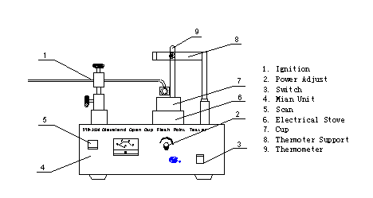
Fig.1

Fig.2
Ⅵ.Installation and use
- Uncovering the package, account the spare parts and check the instrument outside, according to instrument whole set and technical documents, if not be destroyed and loss, it can be installed as structure fig.
- Check electric source, ensure it connected with the ground.
- Turn on the electric source switch, indicator lamp is lighted, test can be started.
- Pour the sample into Cleveland oil cup, up to mark.
- Put the oil cup on the heater, adjust the portfire, thermometer and fire, at the same time to adjust the heating power, now, may test for firing.
- Before the expected fire point 28℃, may test for firing, if not appears flash point, then every higher 2℃, to do test. Every test casts 1s.
- Any point appears the fire, to record the temperature; it is the flash point temperature.
- After testing, clear the instrument, and then cut off electric source.

Ⅶ.Notice proceeding
- Ensure to clearly observe the fire, the instrument should be set in lee and dark.
- The instrument should be set in dry, insulative, un-contaminative, no acid, alkaline and other no caustic air, and keep clear.
- In the course of testing, oil cup should be careful, to protect the glass tube, to avoid to creepage.
- Turn on the electric source switch, to adjust the knob clockwise, if the Ampere meter is still zero, please move on.
- Adjust the heater power, to ensure the instrument used for long time and steady-going, please not make the Ampere meter indicating more than 1.8A.

Ⅷ. Familiar faults and method of dispose
No. | Familiar fault | whys | Method of dispose
1 | Indicator of electrical source is dead. | No power  Indicator is bad  Fuse is bad | Check power outside  Change switch  Change the fuse
2 | Ampere meter no signal | Electrical oven is cut-off  Fuse is cut-off | Change electrical oven  Change fuse
3 | Shell is electriferous. | Grounding is not well | Checking associated circuitry
4 | Heater is not red. | Rheostat is bad  SSR is bad  Heater is bad | Change the rheostat  Change the SSR  Change the heater

Ⅸ.Instrument whole set and technical documents
- Whole set
No. | Name | Total | Remark
1 | Cleveland open cup flash point tester | 1
2 | Cleveland oil cup | 1 | May added
3 | Portfire | 1
4 | Thermometer | 1
5 | Thermometer bracket | 1
6 | fuse | 1 | 5A
7 | electrical source wire | 1
- Technical documents
⑴.Operation & service manual 1
⑵. Eligible certificate 1
⑶. Guarantee to keep the instrument in good repair 1

Checker Packager

Date: Date:

