SYD-2122 Water Content Tester
- to uncover the packing box, and take the operation manual and lid out of box, shown as
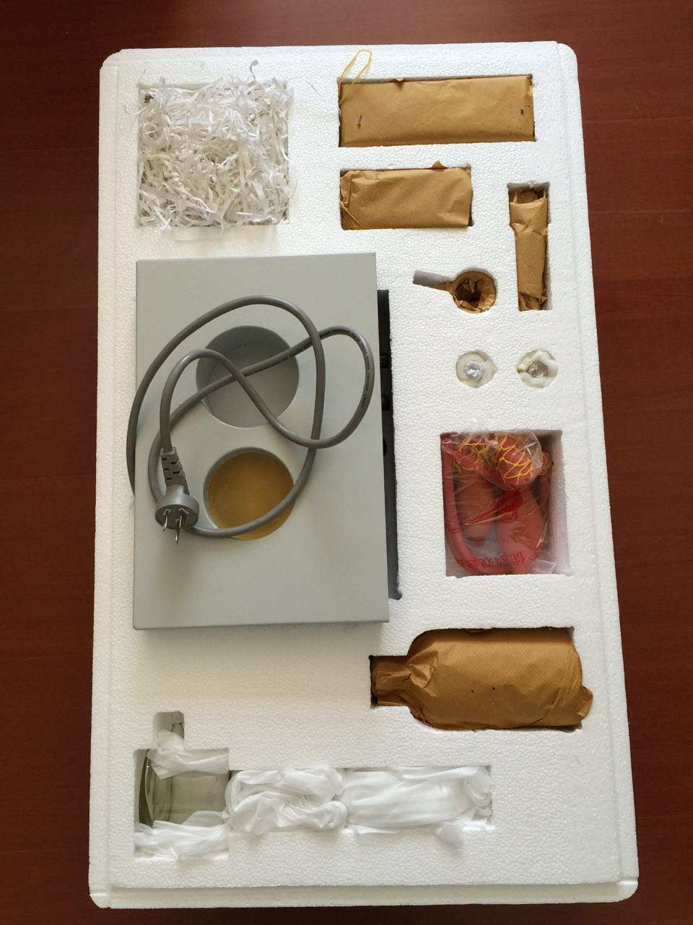The spares and main unit is fixed the location

- to pick the spares and main unit out of the box , the main unit, shown as:
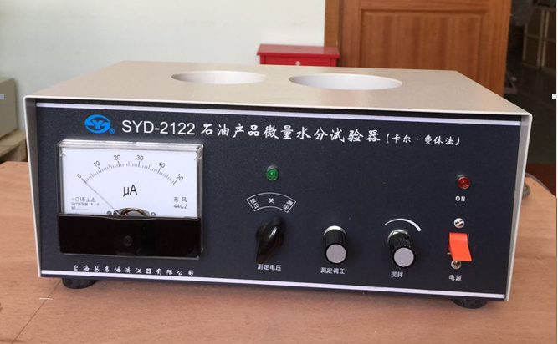
- to put the brown bottle and titrator bottle on the main unit, as shown:
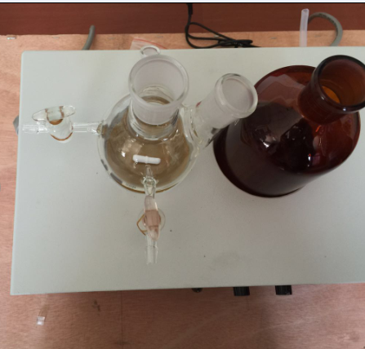
- to put the stopper with two holes on the titrator bottle, shown as
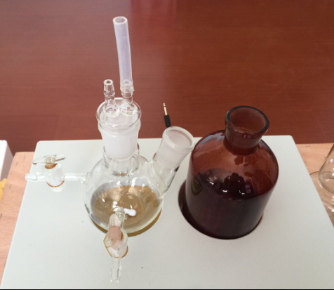
- to install the electrode, shown as
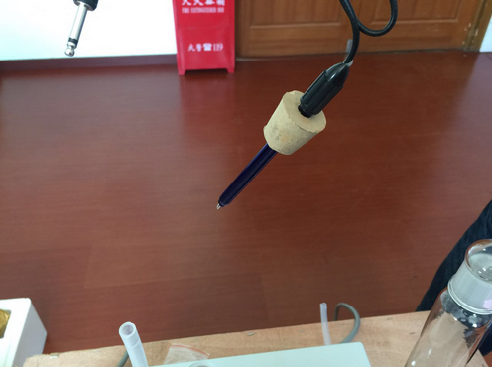
- to install the titration settings and connect titrator and the grown bottle, shown as
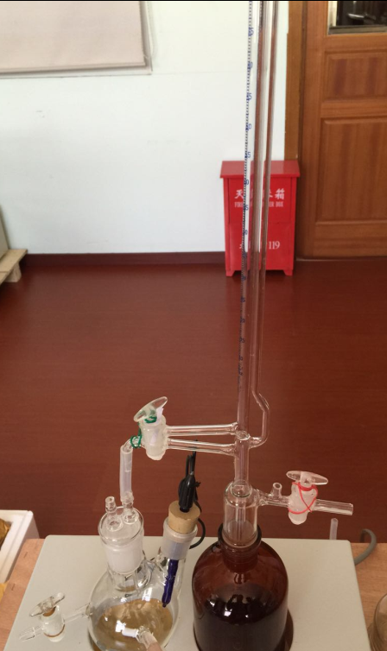
- to install the drying tube on the top of titration settings
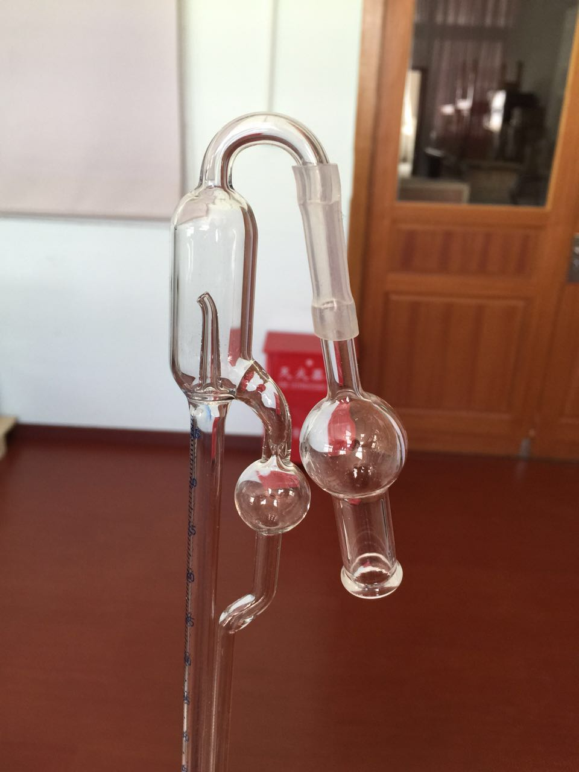
- to install and connect the drying tower and titration settings, shown as
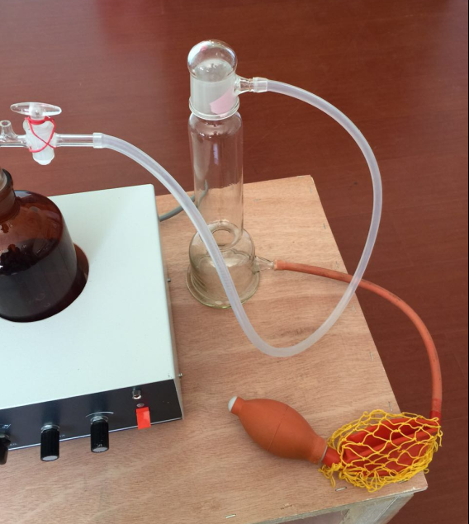

It is OK for installation. Thanks.

Use it, please check the operation manual in English version or refer to standard, thanks.

2015-4-21

