SYD-8017 Vapor Pressure Tester (Reid Method)
- to uncover the packing box, shown as
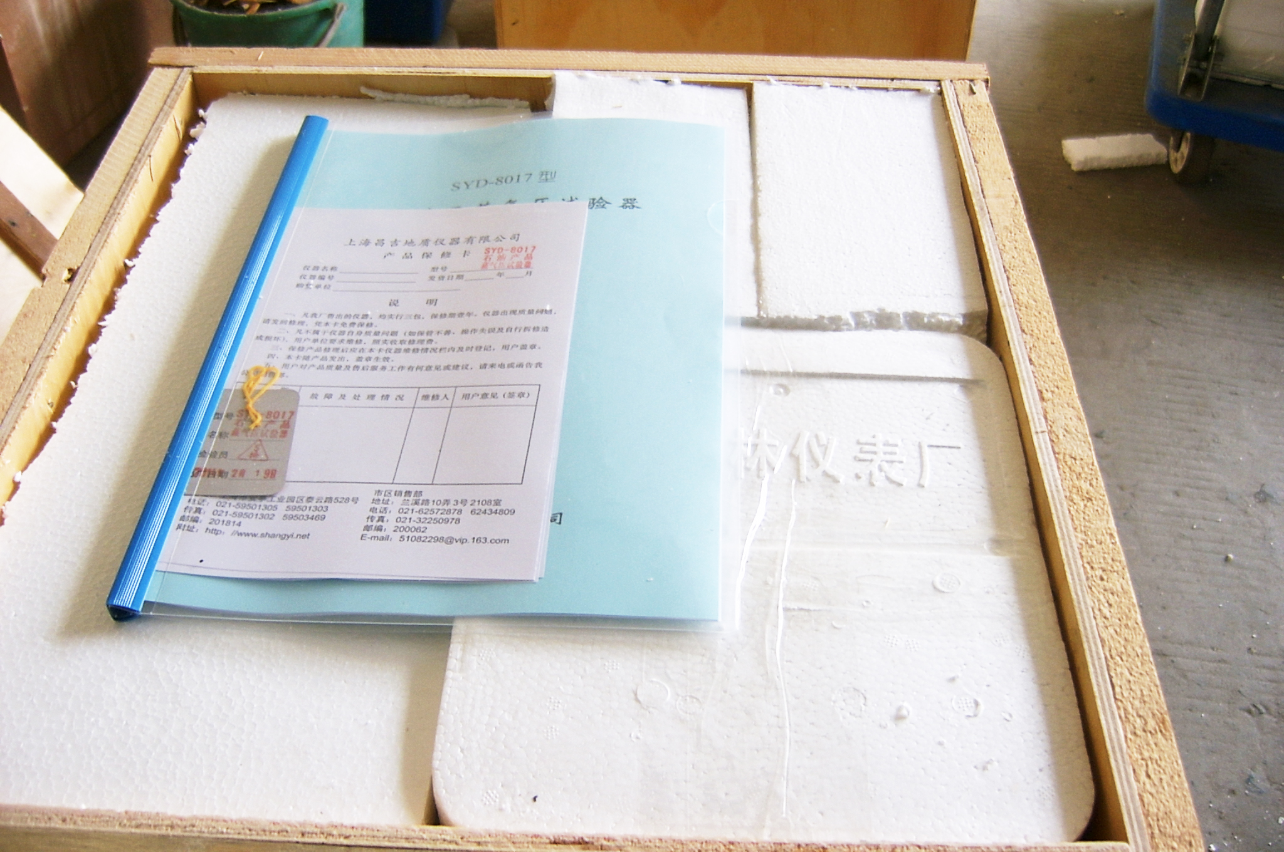

- to pick the spares and main unit out of the box , the main unit, shown as:
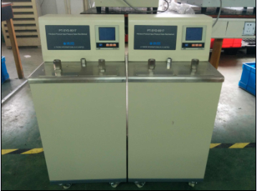

- to install the thermometer with stopper, as shown:
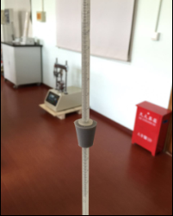
- to install the thermometer and pressure meters in main unit, shown as
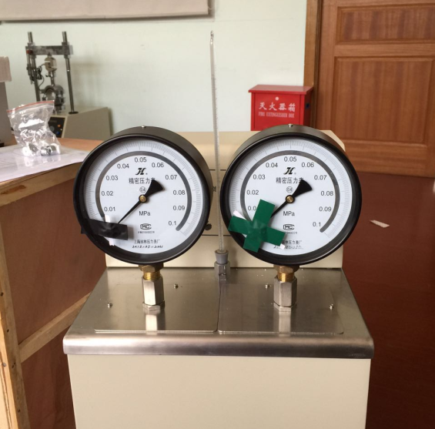

It is OK for installation. Thanks.

Use it, please check the operation manual in English version or refer to standard, thanks.

----------------------------------------------------------------------------------------------------------------------------------------------------------------------------------------------------------------
Robin 2015-4-22

